How To Create a Vial Rack File

Tips:
- Reference premade racks
  - If you are making a new rack that is 96 or 48 premade racks will likely be similar except for z positions.
- Training code is good but be careful when cancelling because there is a high chance of crashing the arm into the rack. Time your cancels to when the arm is moving up to the next vial position and clear from the rack.

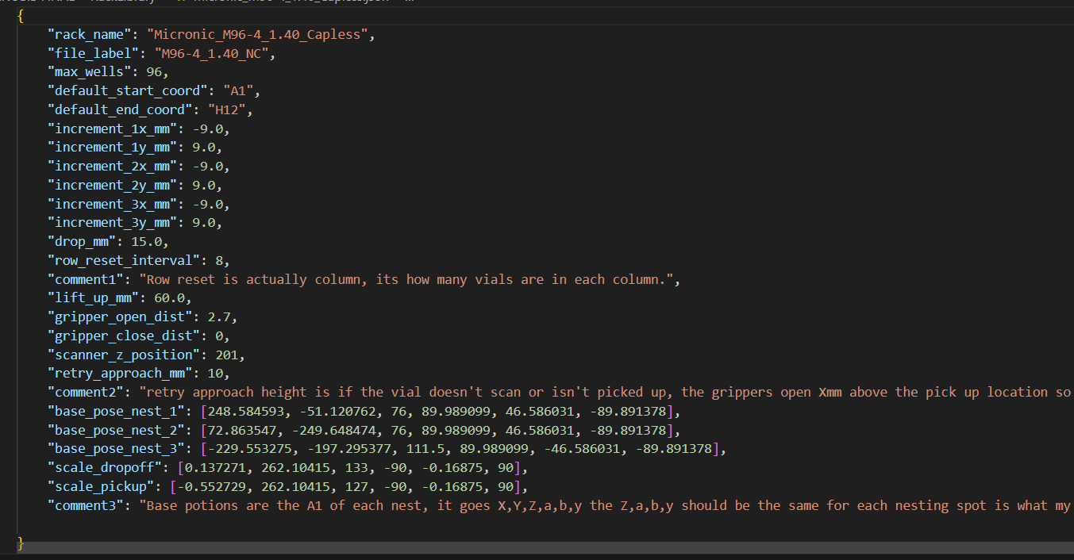

- Rack_name: The name that shows up in the GUI when selecting what vial type you are using. Ensure you describe what rack type, if it has a cap while weighing, and if there is a cap, specify if the vial threads are on the exterior or interior.
- File_label: this is what is specified on the csv files when created. NC means no caps and YC means yes caps.
- Max_wells: This is just how many vials the rack holds but I got too lazy to change the name.
- Default_start_coord: Where the arm will automatically start if the vial rack is full.
- Default_end_coord: Where the arm ends. Ensure that this is matching your rack coordinate grid. 96 is H12 and 48 is F6.
- Increment_(1x-3x)_mm: How much the arm moves back to the next vial in a column. **keep final negative** – Play around with these to see which way it actually moves.
- Increment_(1y-3y)_mm: How much the arm moves to the side to get to the next column.
  - Most rack increments should be the same for each nesting position but double check as ive had problems with the 48 racks.
- Drop_mm: This is not used anymore, it wont affect anything in the code. How far the vial is dropped when picking up from the rack. This is for vials with NO CAPs in an attempt to loosen them from other vials (not always successful).
- Row_reset_interval: How many vials are in each column. Used to let the arm know when to move to the next column. (should say column reset but if you read this you understand).
- Lift_up_mm: How far up the vials get lifts from any given resting point (scale,rack). Make high enough to clear the vial rack. (I make mine have more than a centimeter clearance).
- Gripper_open_dist: The maximum width the grippers can open. Set accordingly to the vial rack to ensure fitting between gaps without being too wide where it hits other vials.
- Gripper_close_dist: Max close distance. Make it close just enough around the vials without too much force.
- Scanner_z_position: distance from the base of your vial to the top of the barcode scanner. Try to make close to ensure a read from the scanner. Don’t let the vial hit the scanner.
- Retry_approach_mm: If a vial isn’t grabbed or read properly this distance is how far above the nest z position the arm goes before opening its gripper. This is important because for some reason the vial isn’t picked up from the rack, the grippers open above avoiding a potential crash into the vial.
- Base_pose_nest: (x,y,z,α, β, γ) The hardest part of making a vial rack definition, this is the A1 position of the rack in each nest. The vials are picked up at a diagonal angle so the grippers can get around the vials without hitting other vials. I recommend not touching the α, β, γ unless it is absolutely necessary. X,Y,Z coordinates are trained through the meca500 api using its ip address: 192.168.0.100. I would try using other premade files and see if the coordinates work for your new rack.
- Scale_dropoff: this is the drop off position to place vials into the holder on the scale
- Scale_pickup: this is the pickup position to grab vials from the holder. There is a slight angle on the scale holder to the pickup may be slightly different than the dropoff.
- Rack Training Help: Paazougi19@gmail.com, (516)-469-6006

